Discussion topics and prompts for MATH

The document below is a shared resource of discussion topics and prompts across several disciplinary mathematics courses. They are sourced from your mathematics colleagues (with attribution), from evidence-based sources such as research on stereotype threat, implicit bias, and inclusive teaching practices, and from sources openly available on the Internet. This is meant to be a working document in that we encourage and appreciate your own additions to this document through sharing discussion prompts that you use and you have found to be effective in engaging students in thoughtful, meaning-making, collaborative peer-to-peer and student-instructor discussions.

General Guidelines for Writing Math Discussion Prompts (Source)
- Exploratory question: Ask students to state in their own words how to work a particular problem or to explain a particular concept or process. Exploratory questions allow you to gauge whether your students are grasping a particular week’s concepts.
- Challenge question: Ask students to reflect on an issue related to math (teaching methods, math anxiety, etc.) and to form an opinion on the issue. Challenge questions are best suited for issues that don’t have a clear-cut answer or where debate exists. With this type of question, you encourage students to think critically and to engage in constructive dialogue.
- Relational question: Ask students to relate a concept covered in class to a real-world scenario or to compare and contrast different procedures. Relational questions force students to see the connection between the subject of the course and real life.
- Diagnostic question: Present an incorrect solution to a problem, and then ask students to 1) analyze the problem, 2) identify the problematic step(s) to the solution, and 3) solve the problem with the correct steps. Diagnostic questions encourage students to apply critical-thinking skills to solve a problem and demonstrate their comprehension of a particular concept.
- Action question: Ask students to solve a given problem. The particular problem may be one that students can solve in more than one way. Students must then post their solutions to the problem before viewing other students’ solution. Action questions gauge students’ comprehension of a particular concept and their ability to problem solve.
- Summary question: Ask students to summarize—in their own words—the various concepts covered in a particular week. Summary questions force students to think through what they have learned and succinctly state main ideas.
- Other types of questions include cause-and-effect questions, extension questions, hypothetical questions, and priority questions.

Icebreakers
- Assessing pre-knowledge
  - Myths and facts about math
  - Fears and competencies (what I am good at and what I fear or need to improve)
  - What do you already know about <subject>? What do you want to know more about? What have you learned so far?
- Building community
  - Meet your instructor! Share tips for study, success strategies used by past students including yourself, what it means to “do math” or think mathematically to boost math literacy.
  - Where I’m from (place/community)
- Affirmations of ability and connecting to student lives
  - What Matters to Me
  - Mindset quiz, video, and discussion (prompts below)

Reflective prompts
- What did you learn in this module? What still confuses you (you feel stuck on this)? What was your study process and what would you do differently/improve next time?
- Construct knowledge – use lower level questions to have students articulate their knowledge base (what did I learn/what do I know; can include definitions and examples) and then move them to higher level questions (where do I apply this? How does this work with another concept or new concept I’ve learned (synthesis)? How would I teach someone else this concept?
- Explain and defend your strategy (the process you used to complete this exam/quiz/project) for this activity.
- How does what we just learned apply to your life? Does it apply to how you think about something, how you do your job, how you approach new learning about this topic? How might someone think differently about this topic?

Applied Math Concepts

- Muddiest Points (Peer-to-peer learning and identifying learning bottlenecks or barriers)

Muddiest Point (shared with permission by Miriam Dash)
Step1. Review Chapter <> and come up with two (or more) things you found confusing or had questions about from the material. Post what these two things are (or ask your question) for your initial discussion post by THURSDAY 7PM. Be Specific! Do not say, I found the whole chapter confusing. State specifically what you found confusing or what you had a question about!

Step 2. Reply by Sunday 5PM to someone's initial post by either answering one of their questions or explaining what you did to better understand what they were confused about. Only reply to questions/things that no one has already answered. Do this for (at least) two different people. Feel free to provide links to outside resources, page(s) from the etext, or anything else you think might be helpful.

Step 3. Once someone has responded to one of your questions, reply to let the person know if their response helped answer your question or to better understand something.
"For this discussion we are not using the post first requirement." Please check the discussion every day to see if someone answered your post.

Additional thoughts:
It is expected that you would have reviewed at least one section of the assigned homework prior to Thursday post. Please ask questions to topics you have already reviewed in the assigned homework assignments.
Please review all of your classmates questions before posting your question. This will avoid duplication of questions. Also, make sure your questions has not been already answered before posting. Also, please check the discussion forum daily to make sure you respond to the persons that may have answered your question or have a follow up question to your solution. Please ask as many questions as you like through Monday morning.
This will give me time to answer questions that your classmates have not answered.

- Teach each other math!
Post one problem from the homework/quiz that you struggled with the most (or you got wrong and not sure why). Explain your steps as best you can.
Post one problem from the homework/quiz that you did well on and understood the best. Explain in steps how you solved it.
Review your colleague’s posts and reply to at least one post with a step-by-step explanation to help them learn how to do the problem they struggled with the most. This could also be a strategy suggestion – don't just give them the right answer! Talk out the steps and path to the solution!
If we get stuck on any problem, tag me (the instructor) in the discussion post and I will step in to help guide the class to the right answer, including the steps taken to solve.
- Homework Help: This weekly forum is used to post questions and requests for help on specific topics or problems from the homework. Post a problem you got stuck on. Provide all of your work so far on the problem so we can see your thinking and process. Review other posts to help others out with problems you solved – don't just give the right answer! Guide your colleagues in the steps to the solution and ask them to try it!
- Alternate solutions: Post problems that have more than one solution and have students work together to solve them.
- Math history and cultural contexts: Have students research the history of a particular mathematical concept and discuss how it is used/applied today.
- Math in the news: Have students find a news article or cultural situation from the past week and post it for discussion. Guide them in identifying topics that are math-related and provide some examples of what to look for.
- Growth & Fixed Mindsets
First, please take this brief mindset quiz (Links to an external site.) and save your answers so you can use them later. Then, please review the below Youtube video. Please reflect on your quiz results and what you learn from the video below. Give an example of a growth mindset and how it relates to your life. Please keep your answer under two paragraphs.
Please respond/comment to at least one of your classmates. Observe any differences or similarities between your approach to something you enjoy (growth mindset) or something you might dread (fixed mindset). Explore why you think you may take a growth mindset over a fixed mindset depending on what the task is. Ask for more details or any gaps in the discussion you notice (did they miss something or not think of this from another perspective?)
Your initial post is due Thursday by 7pm, giving you until Monday 5pm to respond to your classmate's post but I encourage to visit the discussion board every day to check for responses and to add more to your own posts.

Statistics
- Share an interesting (fun, head-scratcher, dubious, or shocking) stat you recently heard or read. Share the source and ask one probing question about it. Using what you’ve learned in class so far, how can you validate the legitimacy of the statistic, or apply what it means to you or others? Respond to at least one other students’ stat by expanding on the question, discussing what it means or how it might apply to our lives, or sharing more facts about the statistic.
- Implicit Bias test (Harvard) - when using this to introduce students to the concept of implicit bias and the application of statistical data to meaning making, please be sure to contextualize the topic and how we use data to generate sample size and validity. In this particular prompt, it is not recommended that students share their results, but instead that they discuss the process of collecting data and how data is used in our society to address issues of social justice and bais. Using the Project Implicit Blog can give you and your students access to connected data sets, discussions on sampling and tracking social trends, and more.
- What would be an example of the statistical method we just learned applied to a different but similar situation? Instructor: provide the topic or situation or have students suggest their own – this could be a scaffolded lesson in which you first provide new contexts or situations, and then later have them suggest their own.
- Breaking down demographics in math: gender, race, occupation – what assumptions do you have or that others might have about this topic? What new information or insight did you gain? What more would you need to know to better understand this topic?
- (Source: Miriam Dash, CCV Statistics Instructor, shared with permission):
Objective 1: To demonstrate you comprehend the information that is being communicated. To articulate what you believe are the causes of the disparity of incarceration rates between the U.S. and the rest of the world. Articulate what you believe are the causes of the disparity of incarceration rates between White and Black , Latino people.
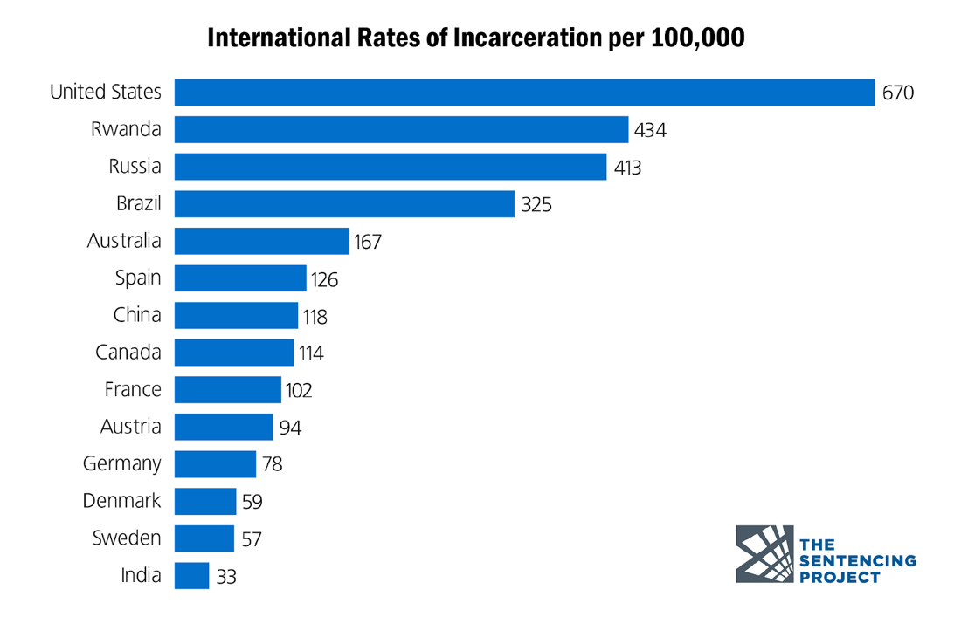

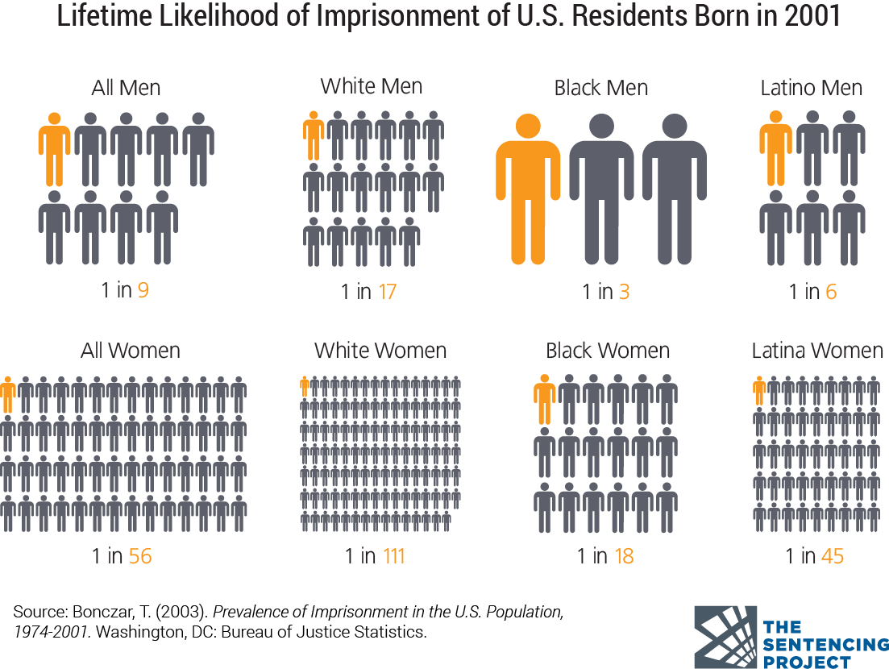
The initial post should be posted by Thursday by 7 PM
Objective 2: After you write your belief of the causes what the watch the youtube video and read the article below. Then let us know if this new information changes your belief or not. Please explain why/why not? Do you think this is true in Vermont? Please explain your viewpoint.

How the 1994 Crime Bill Fed the Mass Incarceration CrisisLinks to an external site.
This post should be posted by Sunday by 5 PM

You must return at least twice, after your initial post to do your assessment of your classmates viewpoints and then answer any questions they may have of you . Please return by Monday at 7pm to answer any questions.

College Algebra

The Laws of Algebra
1. Please read the following definitions of deductive and inductive reasoning. We use deductive reasoning primarily in this course. It is important to learn the laws of algebra. List two rules or laws you have discerned in the week 1 material. Please complete it before the third class.
Deductive Reasoning
What Is Deductive Reasoning?
Deductive reasoning relies on a general statement or hypothesis—sometimes called a premise or standard—held to be true. The premise is used to reach a specific, logical conclusion.
A common example is the if/then statement. If A = B and B = C, then deductive reasoning tells us that A = C.
Inductive Reasoning
What is inductive reasoning, and why is it important? Inductive reasoning is a type of logical thinking Links to an external site. that involves forming generalizations based on specific incidents you've experienced, observations you've made, or facts you know to be true or false.
What comes next?
1,1,2,3,…
2. Post a scenario for your peers to state whether the situation or incident is inductive or deductive (or both!). You can refer to the sample exercises/scenarios in the textbook, but revise to be your own or create a new scenario of your own. You must respond to at least two of your peers' scenarios. In your response to your peers, provide the reasoning for your answer using the rules we've already learned.

Feedback on discussions – suggestions and guidelines
- Prompts to encourage deeper reflection and demonstrations of knowledge
  - You make a very interesting point here. Can you say more about this?
  - Can you explain the steps you took in arriving at this solution?
  - I think I follow you but you lost me right here... Can you explain this in more detail or more clearly?
  - This is a good observation; why do you think …?

Rubrics
Basic Discussion Rubric (adapt to class and assignment)
Criteria | Ratings | Pts
Engagement  Posts are thoughtful, uses a relevant example, and engages with the definitions and applications of rhetorical discourse in your life. | This area will be used by the assessor to leave comments related to this criterion. | 25 pts
Timeliness  Posts are completed on time, and responses are completed on time. | This area will be used by the assessor to leave comments related to this criterion. | 25 pts
Use of details and support  Posts are detailed to meet the requirements of the discussion, and use support to engage the reader and contextualize the experience. | This area will be used by the assessor to leave comments related to this criterion. | 25 pts
Interaction  Responds to others posts with questions, ideas, comparisons, or other discussion elements that provide a rich and interactive experience. | This area will be used by the assessor to leave comments related to this criterion. | 25 pts
Total Points: 100

